**EXPERIMENT – 5,6**

PASSENGERS TABLE :

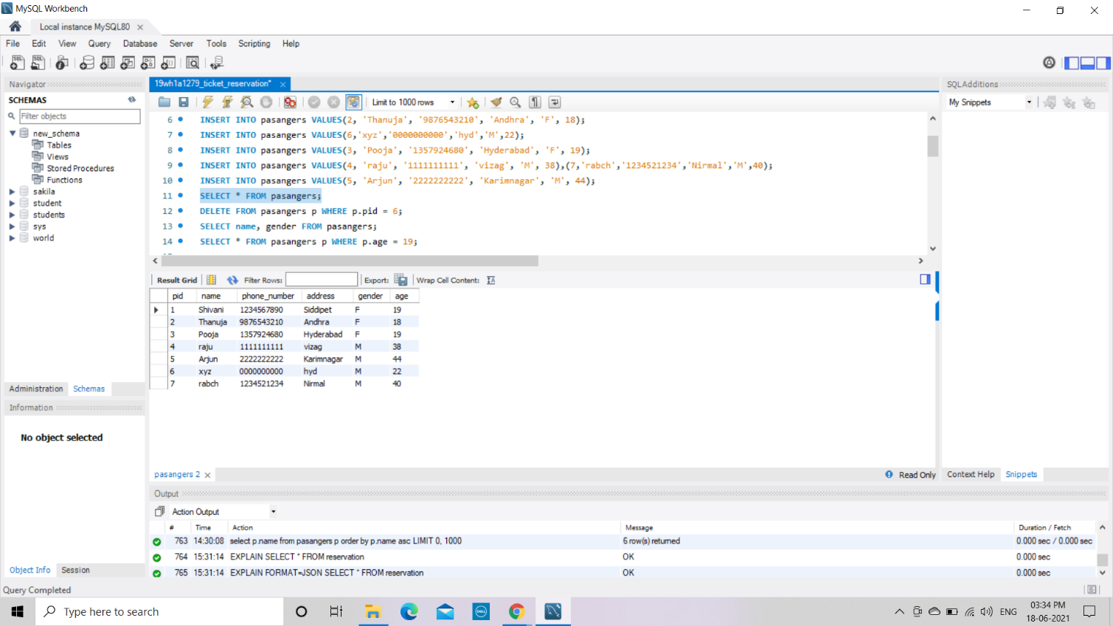

After deleting : (pid=6 is deleted) Selecting Whose age=19 :

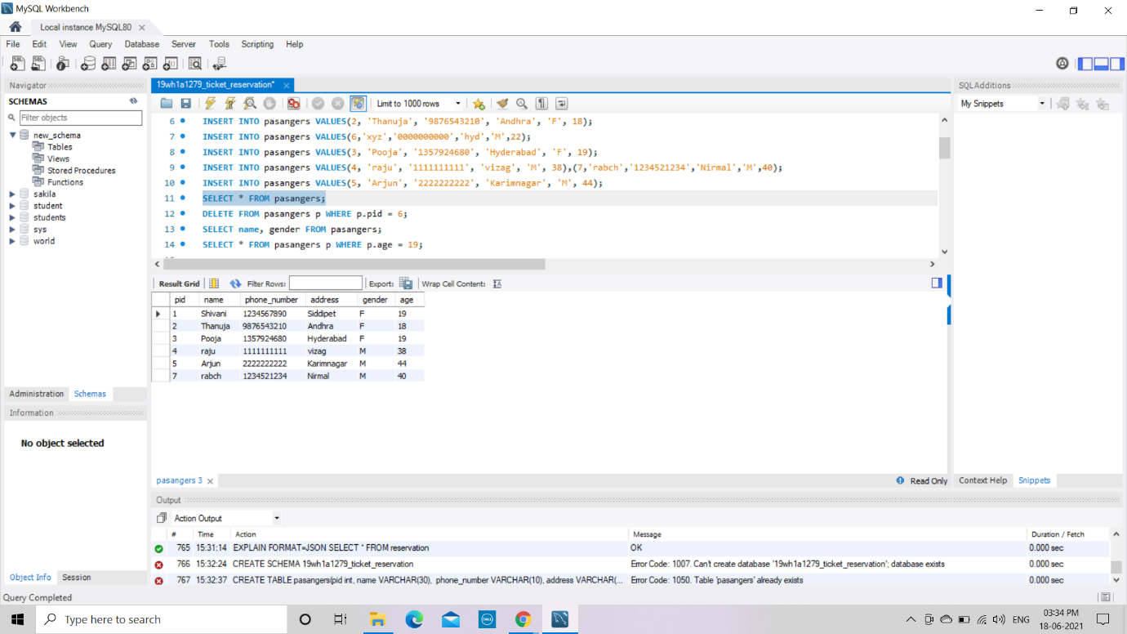 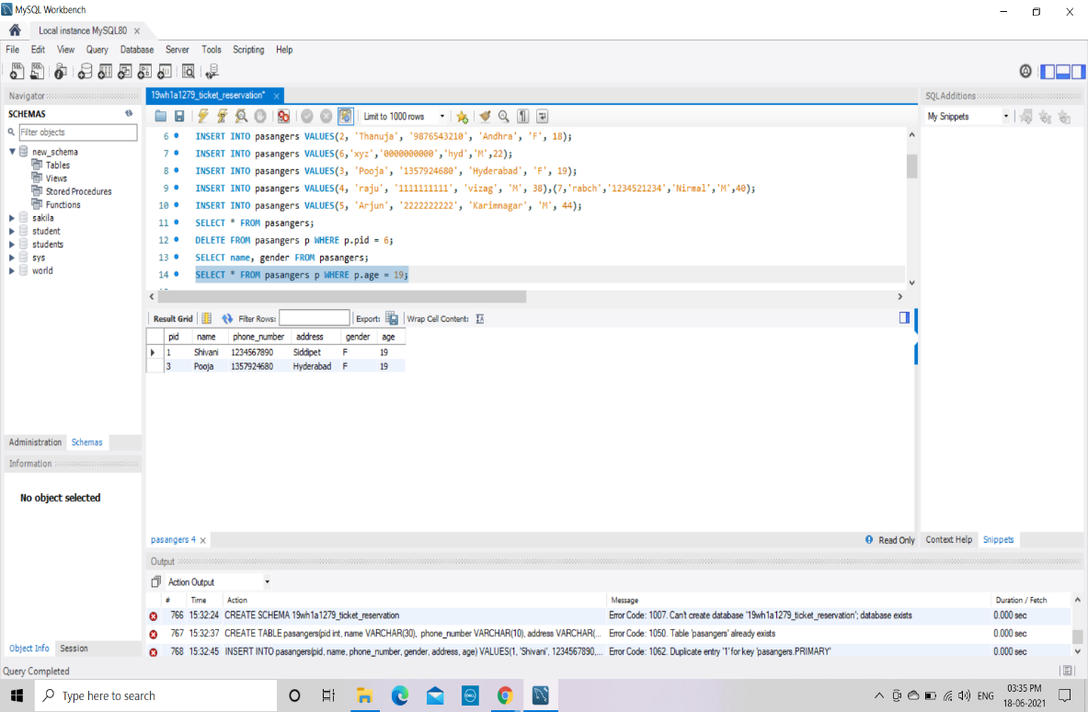

**Bus Table:**

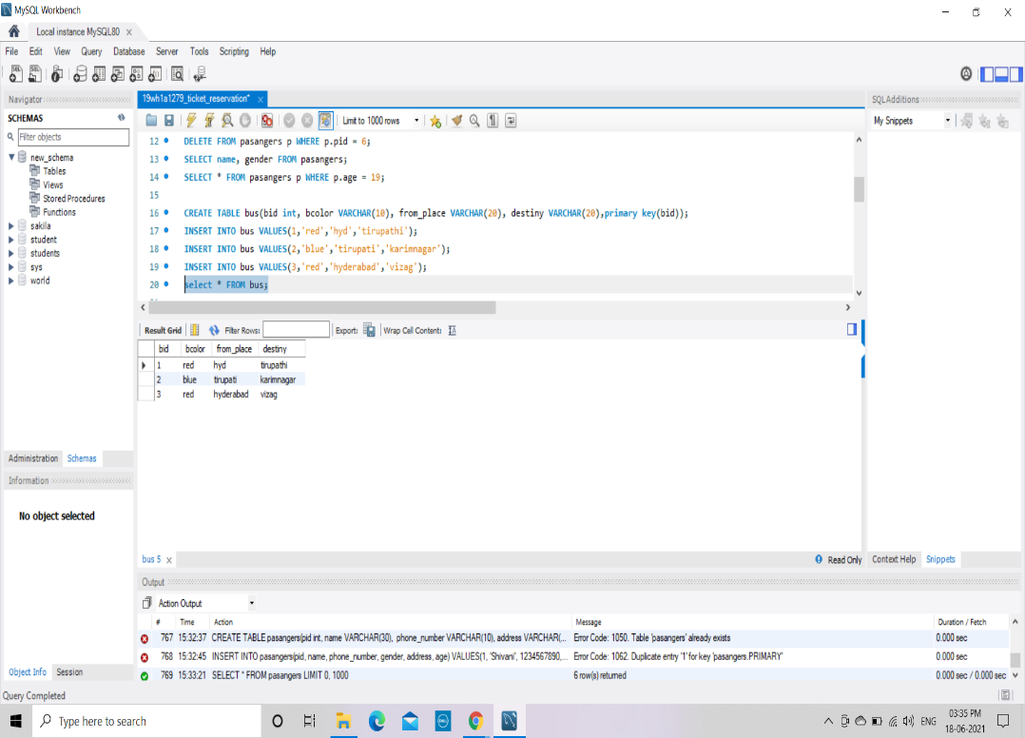

**Ticket Table:**

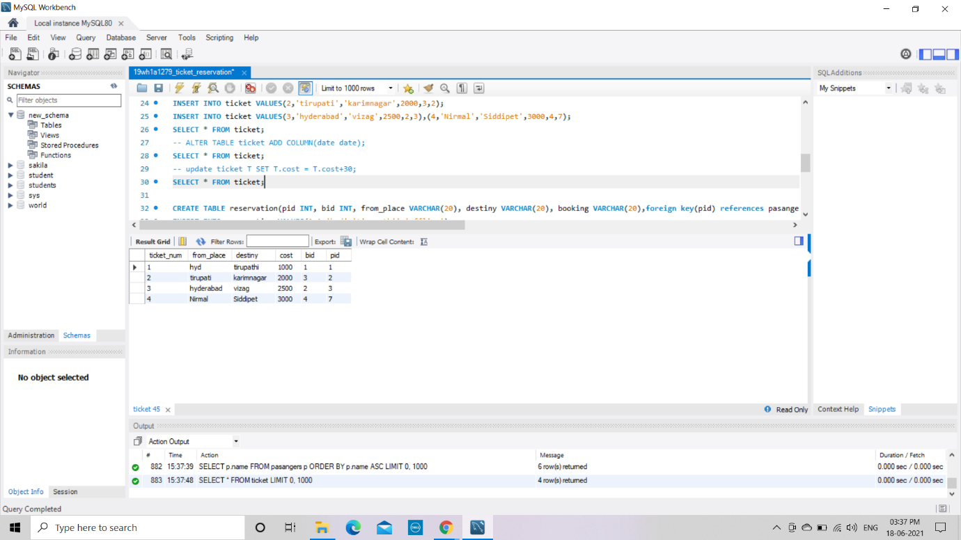

After altering (Adding date column) : After updating the cost :

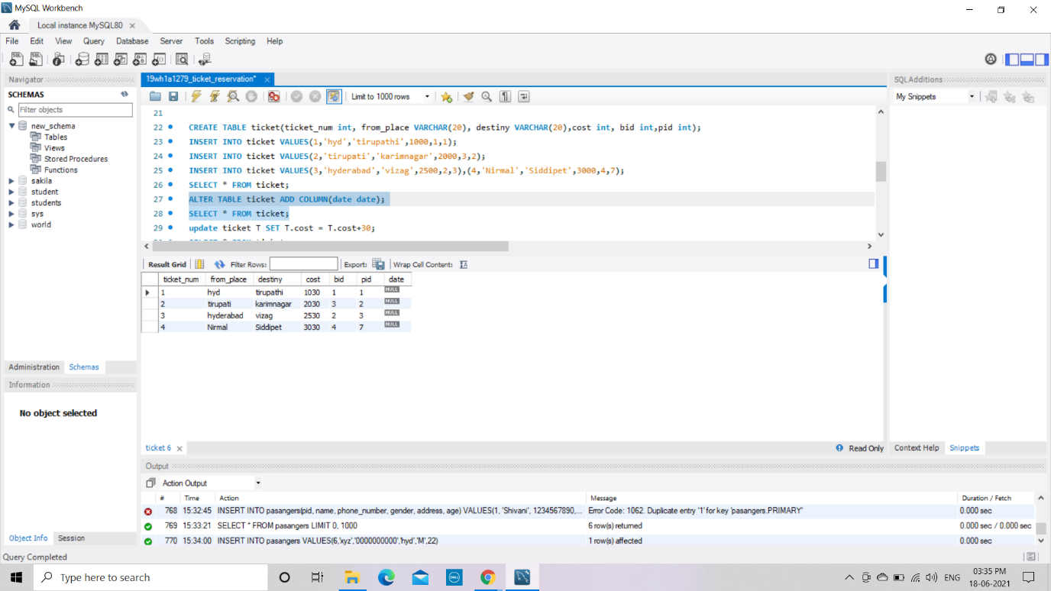 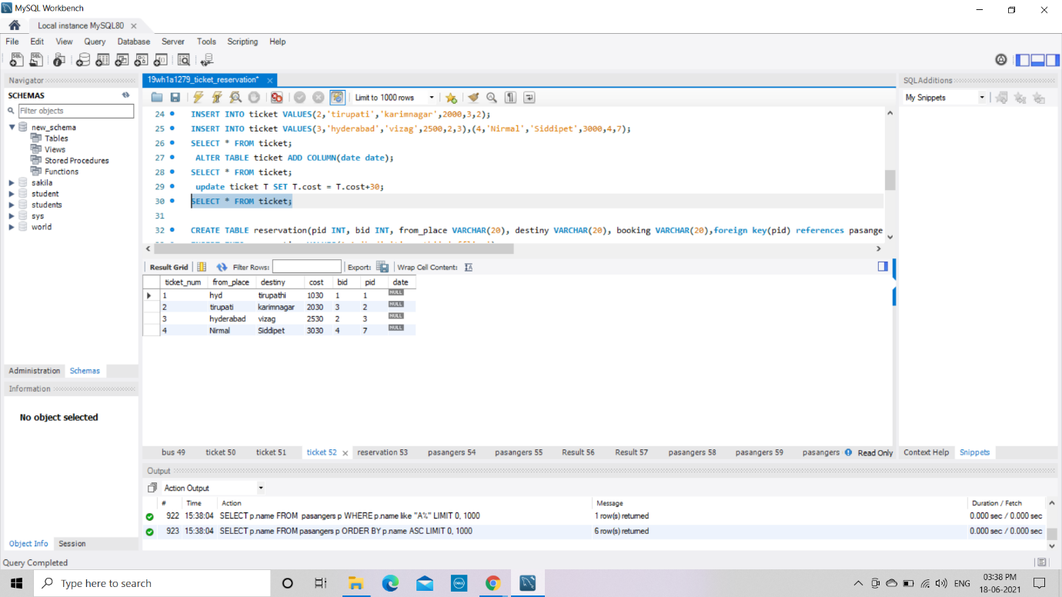

**Reservation Table :**

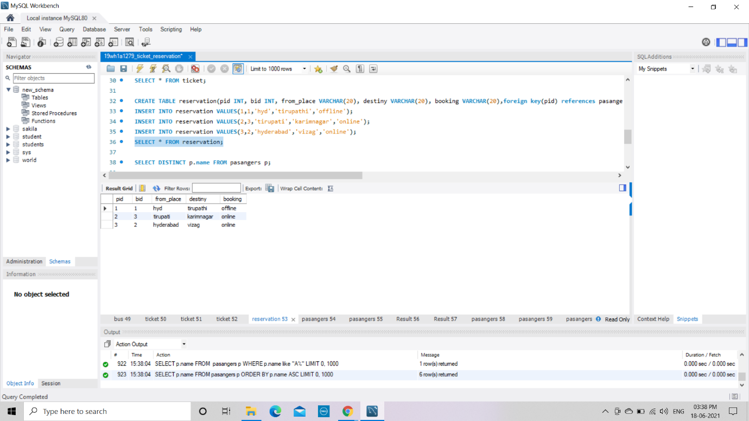

**EXPERIMENT - 7**

1. Display unique PNR_no of all passengers.

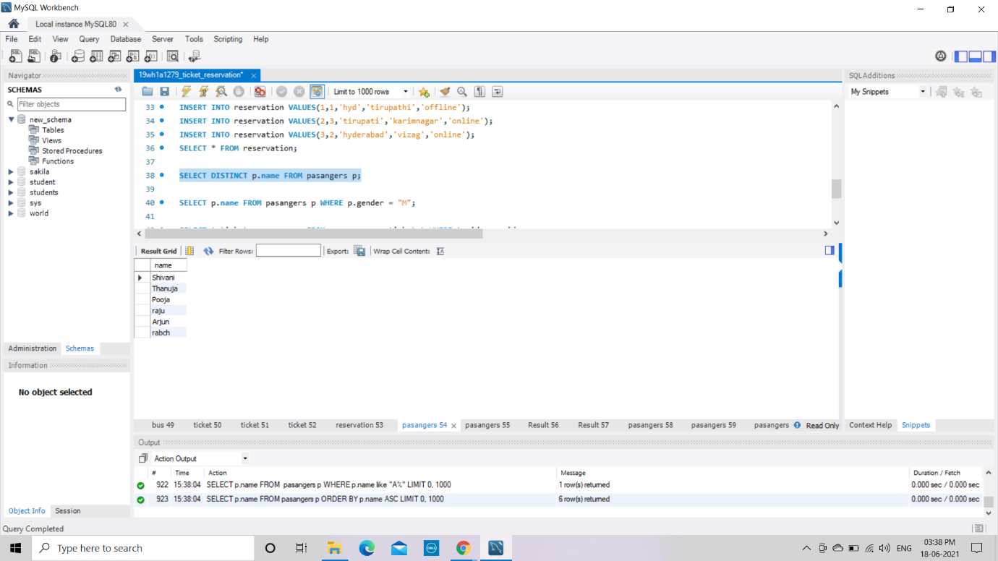

1. Display all the names of male passengers.

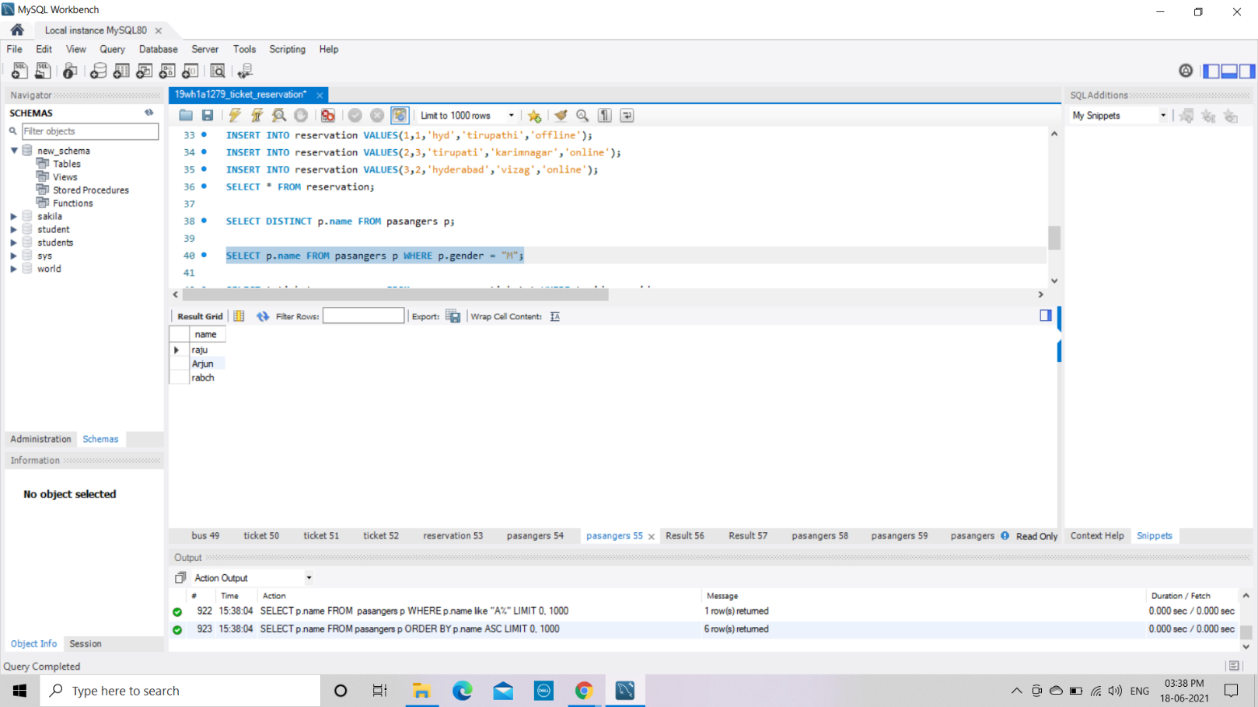

1. Display the ticket numbers and names of all the passengers.

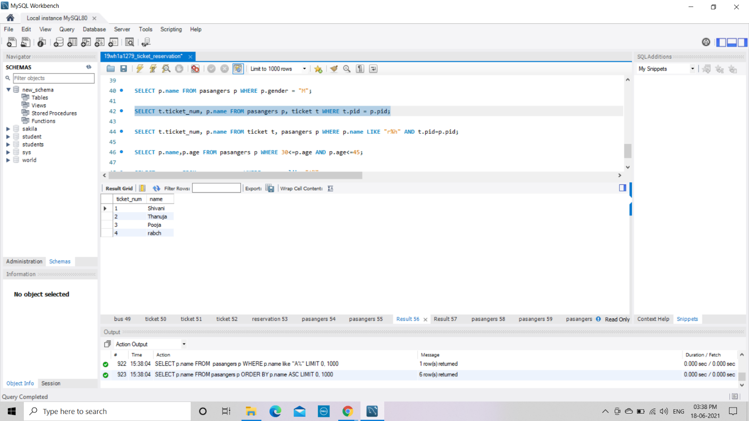

1. Find the ticket numbers of the passengers whose name start with ‘r’ and ends with ‘h’.

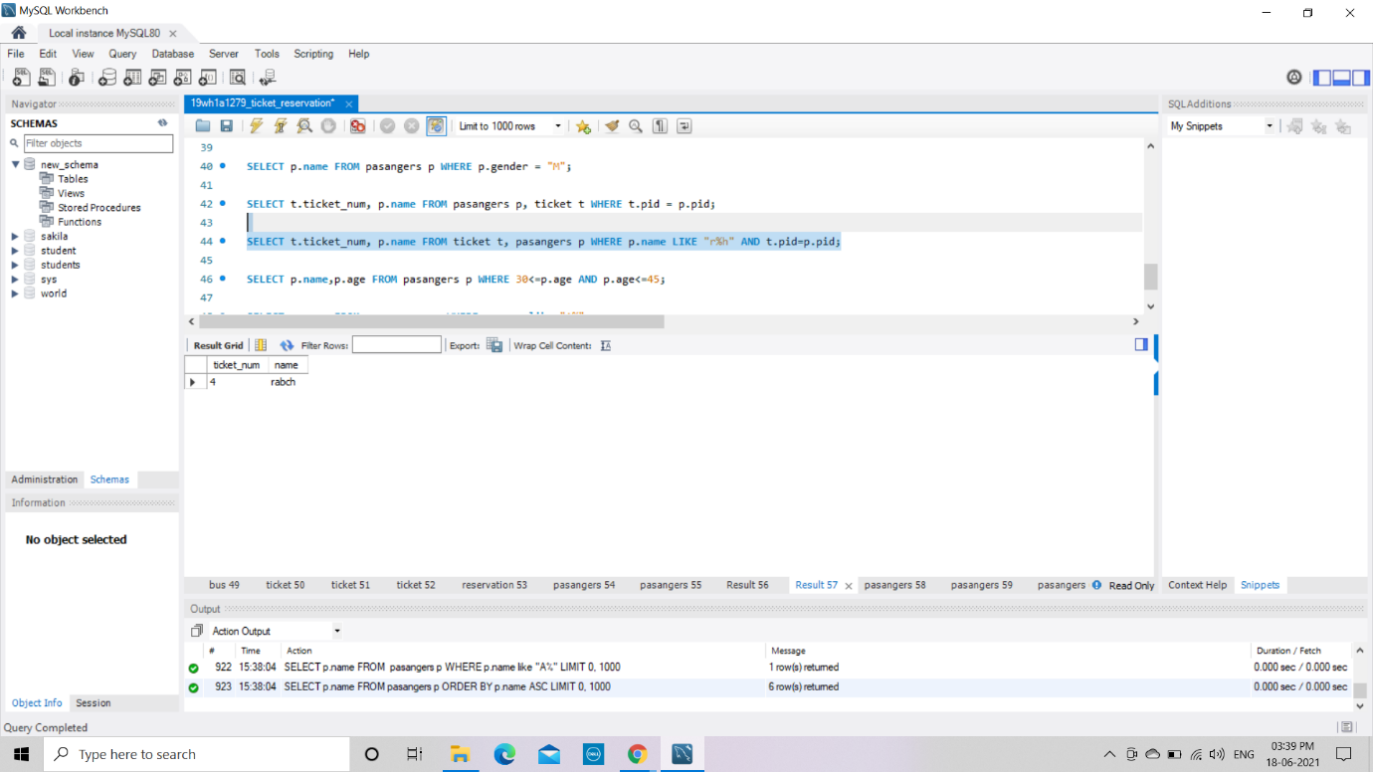

5. Find the names of passengers whose age is between 30 and 45.

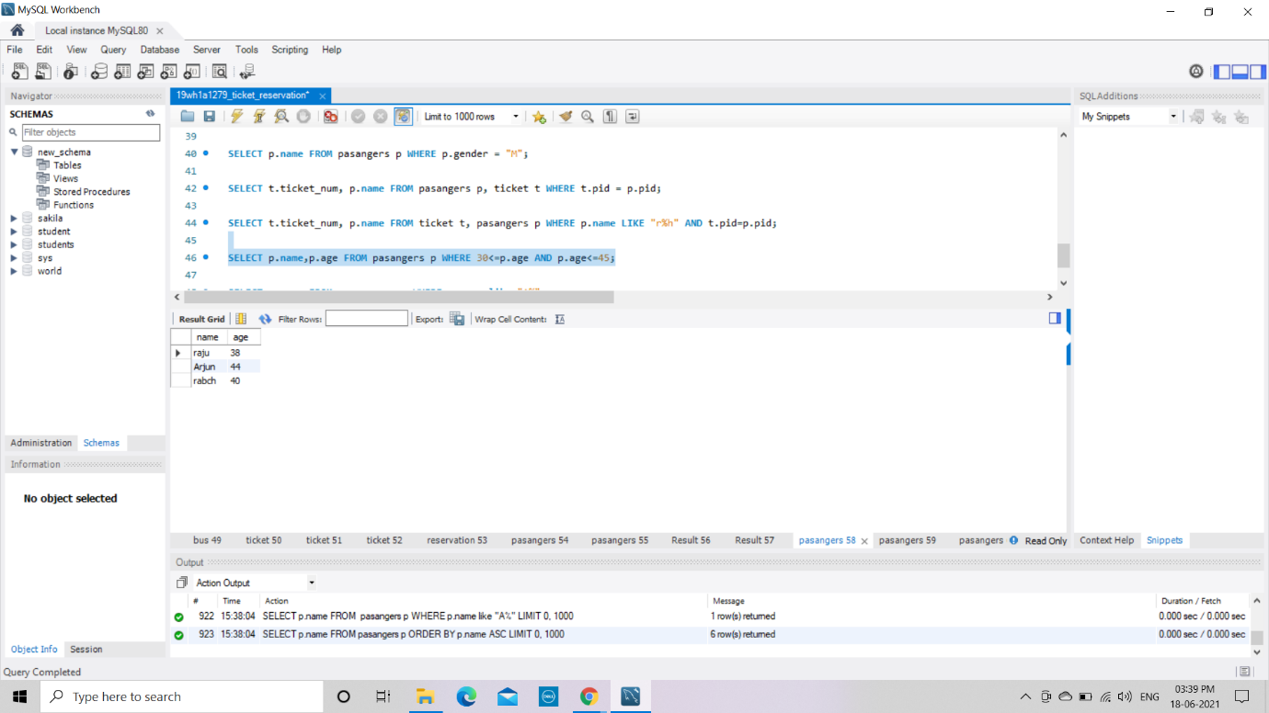

6. Display all the passengers names beginning with ‘A’

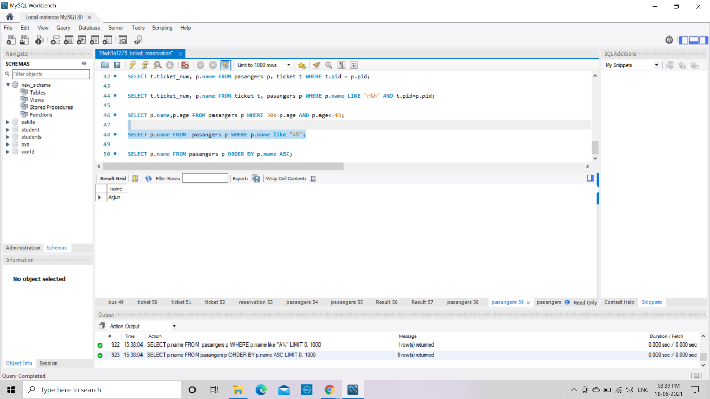

7. Display the sorted list of passengers names

